# **Squad Pharma Care**

Squad Pharma care is a pharmacy software which is responsive Modern design for any kind of pharmacy. This pharmacy software is actually used for pharmacy data management.

It has following module

1. Customer Management Module
2. Supply & Purchase Module
3. Inventory Module
4. Easy Invoicing System
5. Financial Module
6. Product Management Module
7. Daily, Monthly, Yearly Sales, Profit and Expense Report
8. Due Payment Management
9. Choose Any Currency
10. Medicine, Drugs, Customers, Employees, Clients, supplier and Users management
11. POS (Point of Sale) management
12. Search Medicine, Customer, Purchase, Invoices by Its First Letter
13. Sales Graph
14. Print Invoices
15. Generate Report By Date Range.

Application Settings

After login, first thing you have to do is Settings. To do the setting of you application, just go to Setting. In this module you will get all the settings for your application where you can set your company title, menu title, language, discount type, currency, timezone etc.

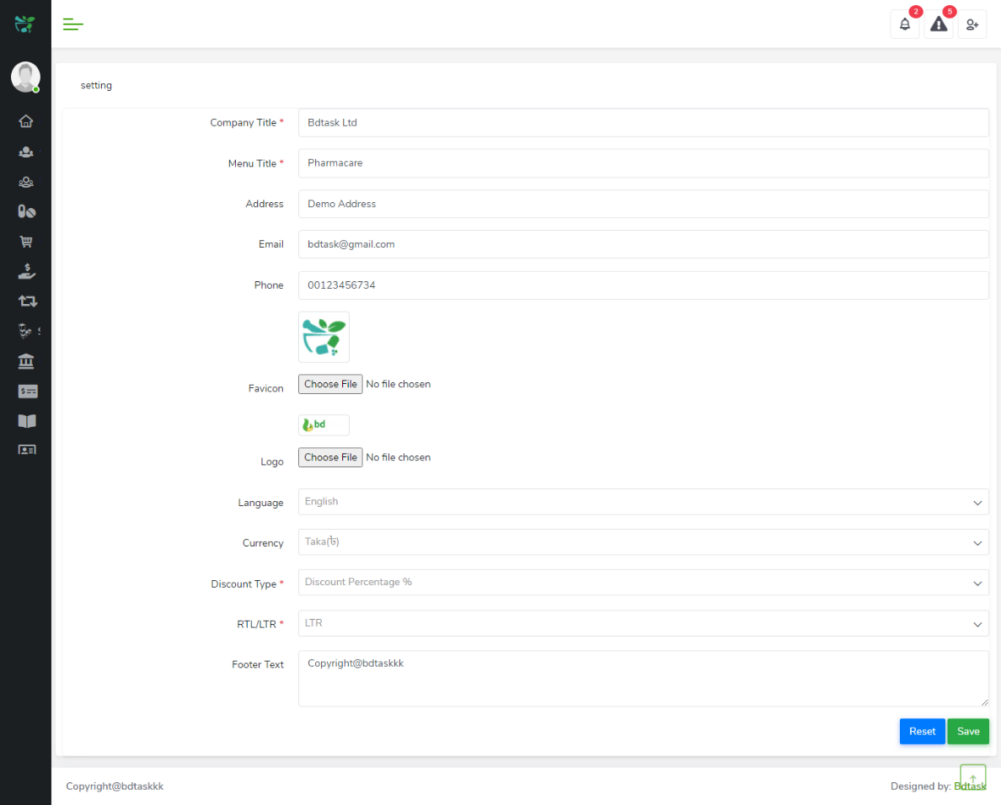  
  
**panel Setting**

If you want to customize the colour and font of your software you can edit them in the Panel setting.

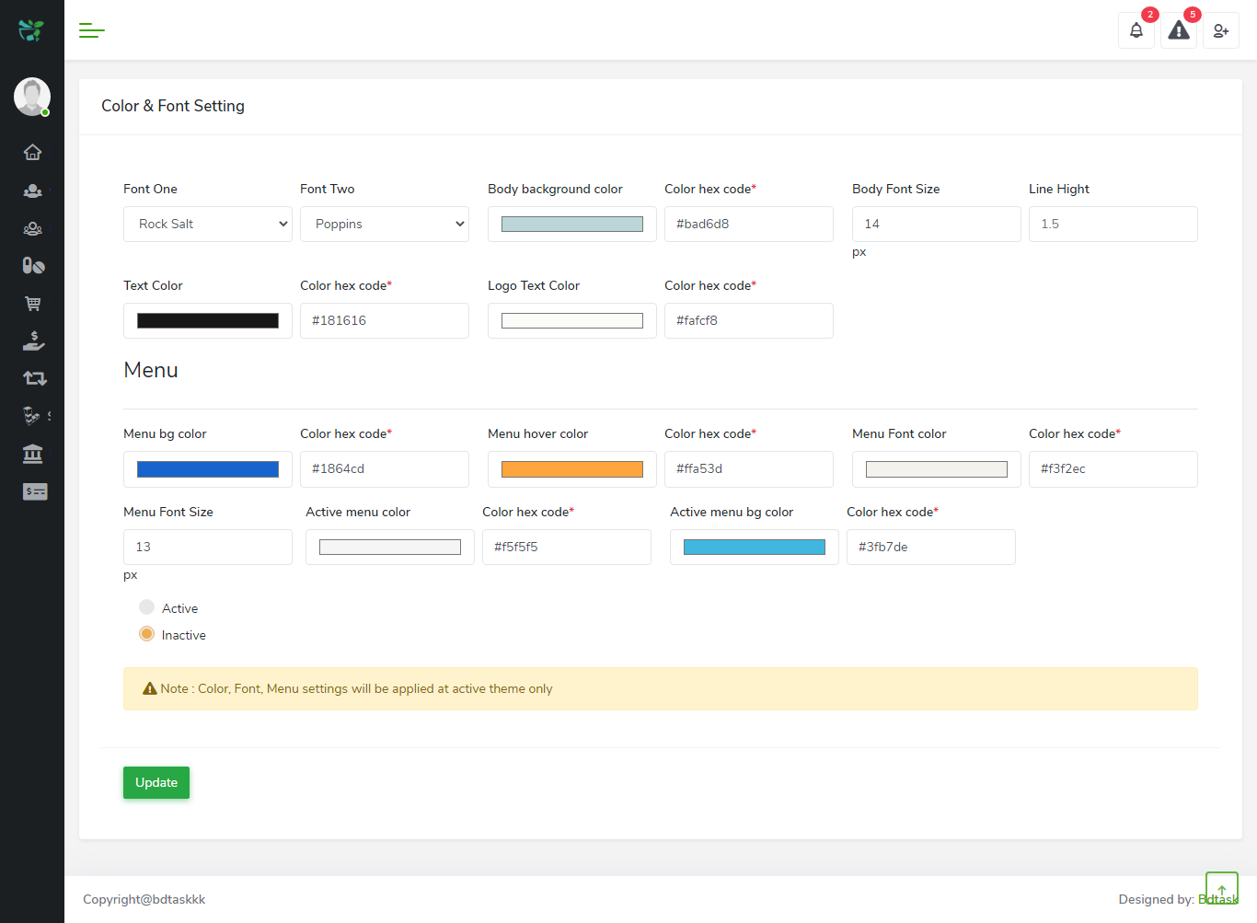  
  
**Language Setting**

You can set the language of the software according to your prefference.

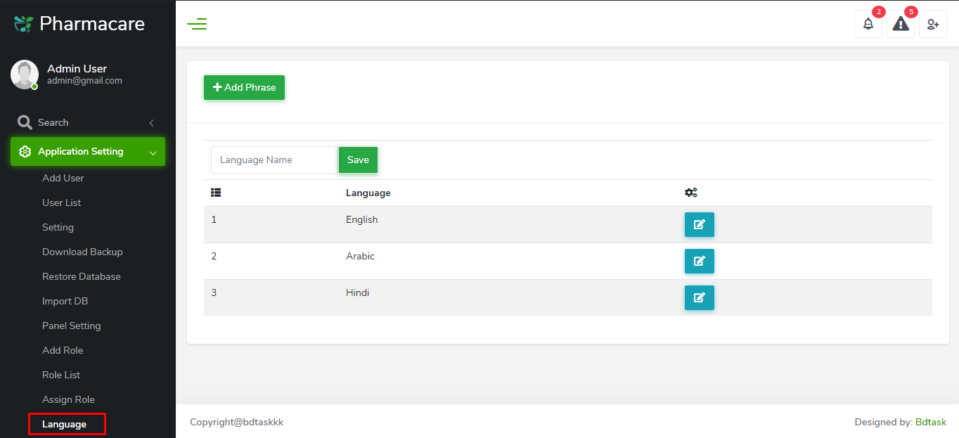

**Add User**

you can add user here according to your need with their necessary information such as name, phone no, email address etc. A password for a user can be set here for his login into the system.

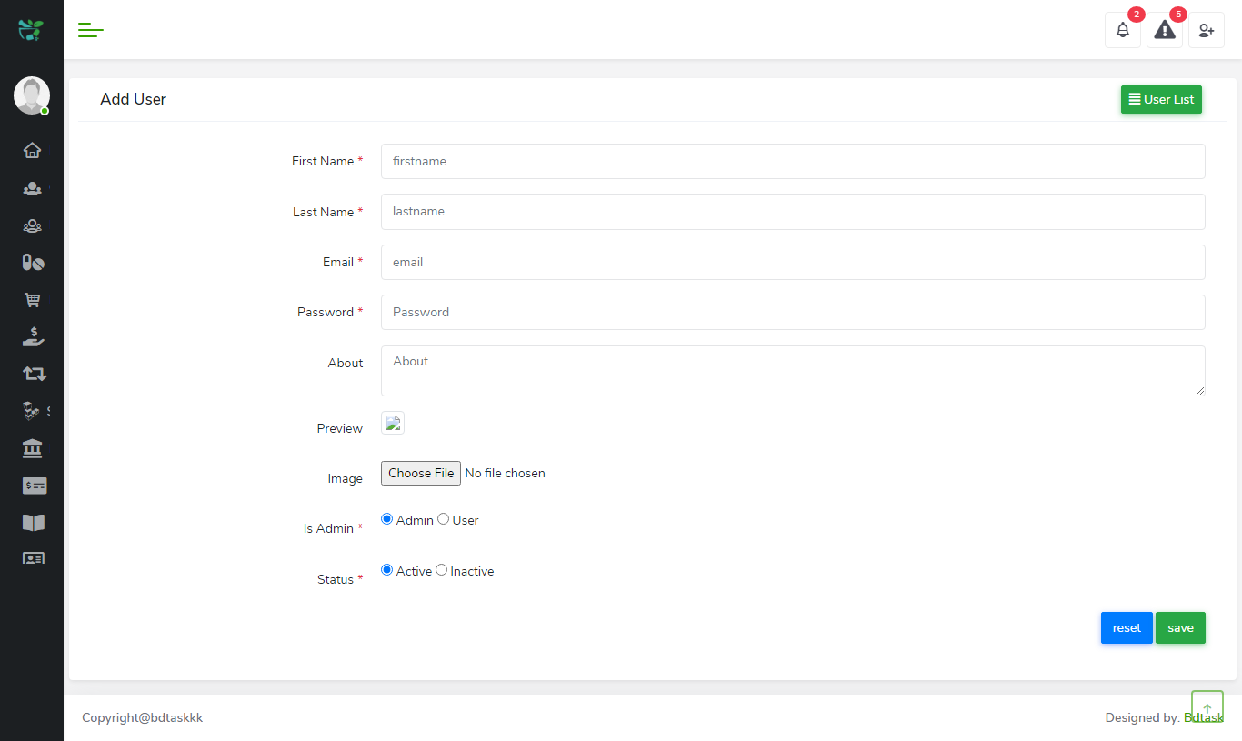  
  
**User List**

You will find all the user list here. Their email address, login information, ip address etc will be listed here.

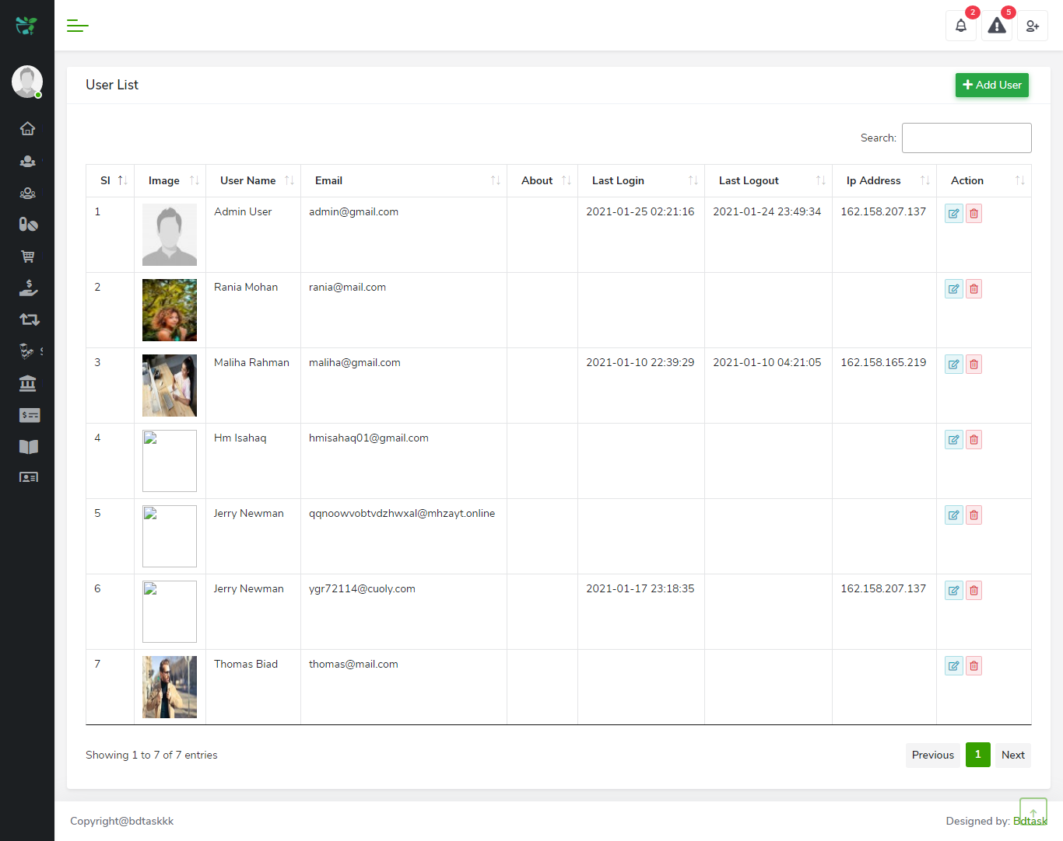  
  
**Add role**

You can create a role from this module. The roles can be customized here. At first Set a role name and assign some modules to that role. There are checkboxes to assign the modules to a role. A role can only work on the specific check marked modules.

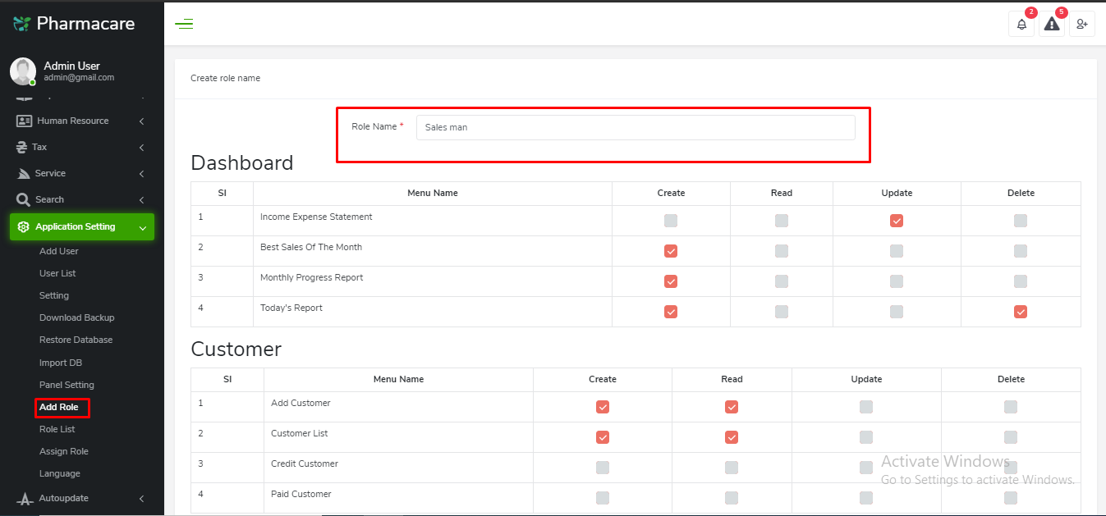  
  
**Roll List**

You can find all the roles in the role list. You can edit and delete any role from here.

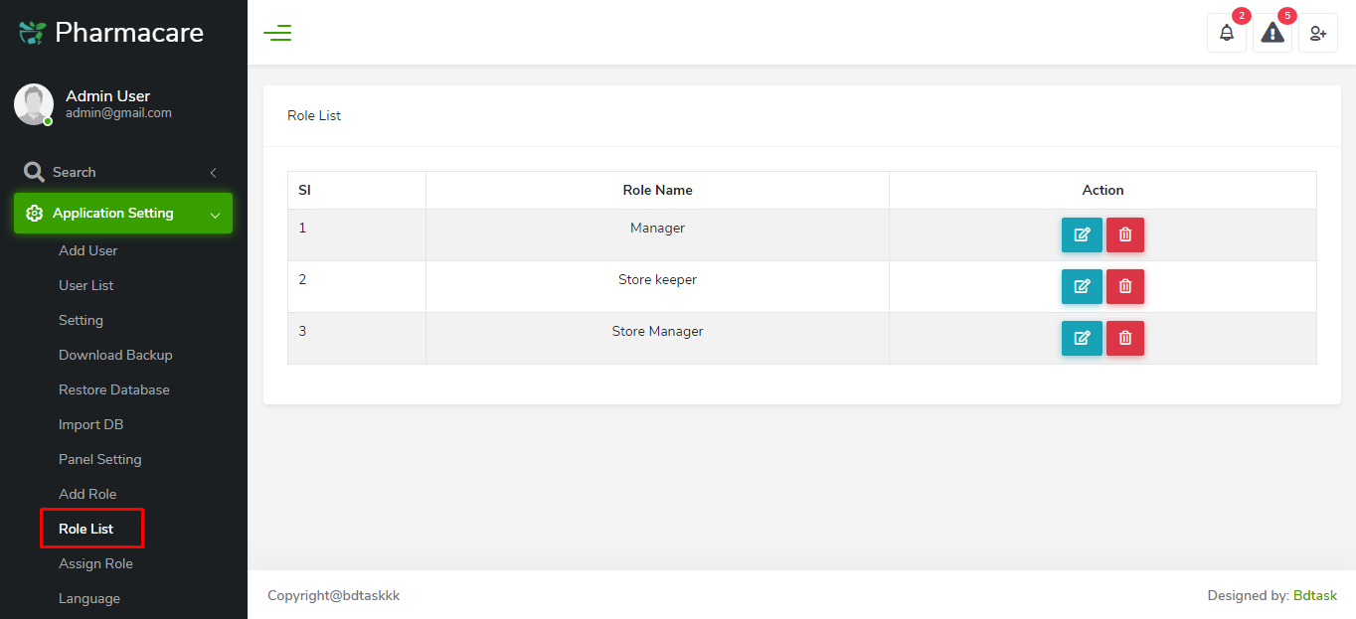  
  
**Assign Role**

You can select a user and a role here to assign the role to that user.

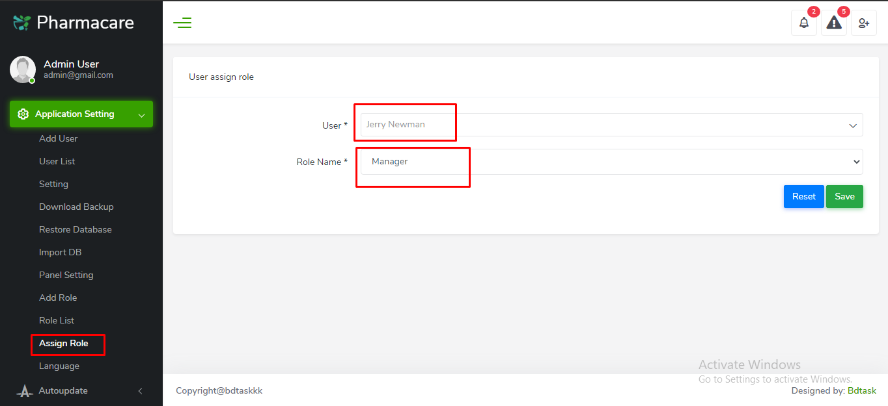

### **Data Backup**

**Restore Database**

If you want to restore your software database then go to Application Setting>Restore Database. If you click on restore button it will remove all of the data of your system. For safety you can download a backup sql file of all of the data at first. Go to Application Setting and just click on Download Backup. You will get a sql file downloaded instantly.

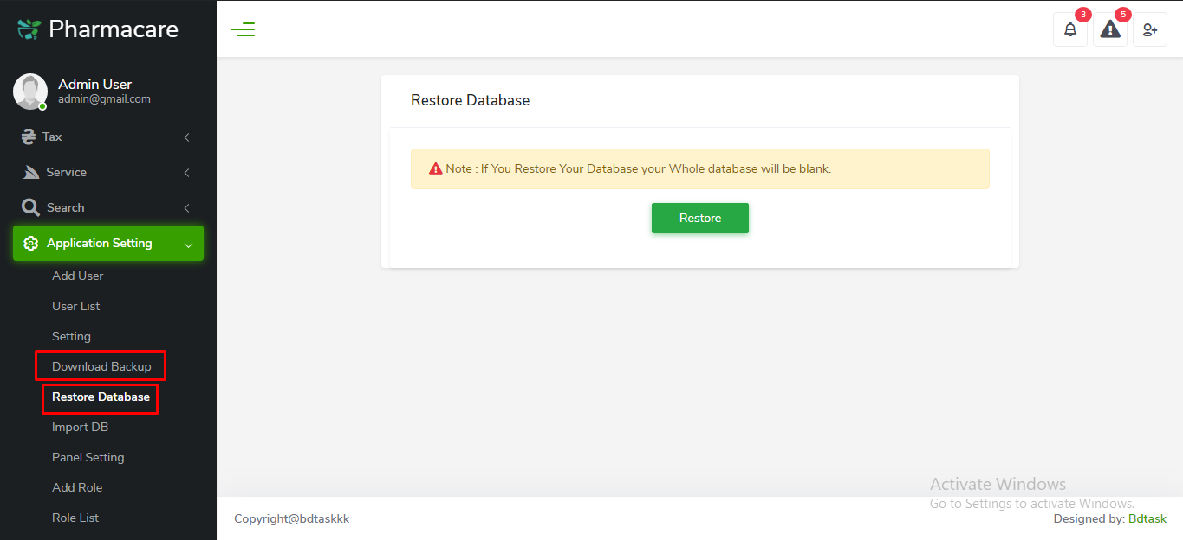  
  
**Import DB**

If you want to import a new database to your system then go to Application Setting>Import DB. Now choose a sql file and upload it. Once you import a new sql file all the previous data will be removed.

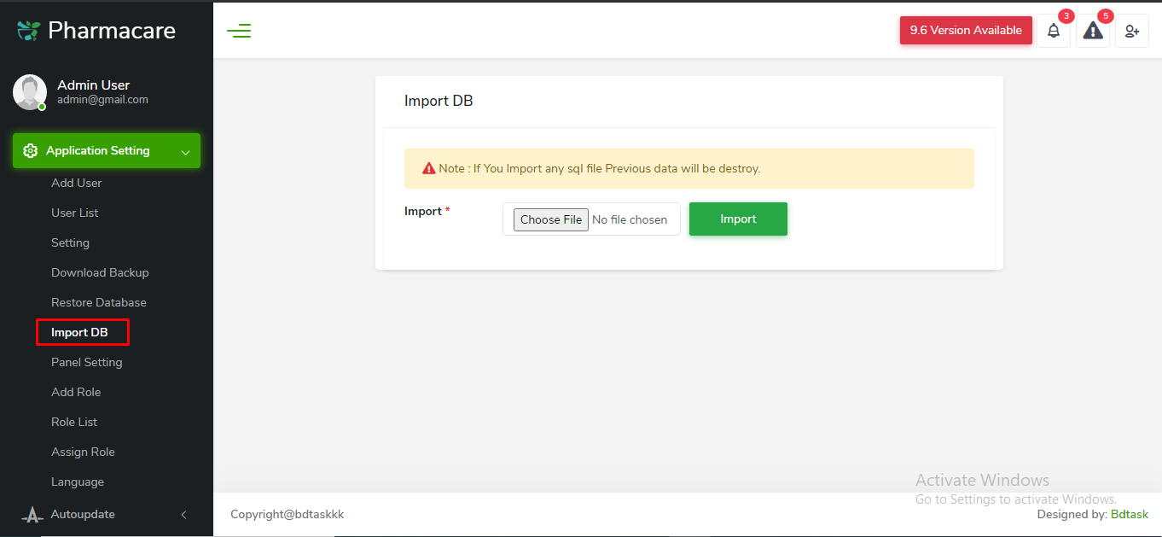

### **Auto Update**

**Update**

The automatic update is a new feature of Pharmacare. This feature is only applicable for V 9.4. After purchasing the pharmacare when a new update is uploaded in our update server. You will get a notification to update your system. Then just go to the “Auto Update” page, enter your purchase key, select the version and hit update.  
  
Note: before you update your system, we recommend you to download a data backup for safety. Because, after the update, some data might be missing. Go to Application setting>download backup. A sql file will be downloaded. After updating your software upload the sql file to the import db page.

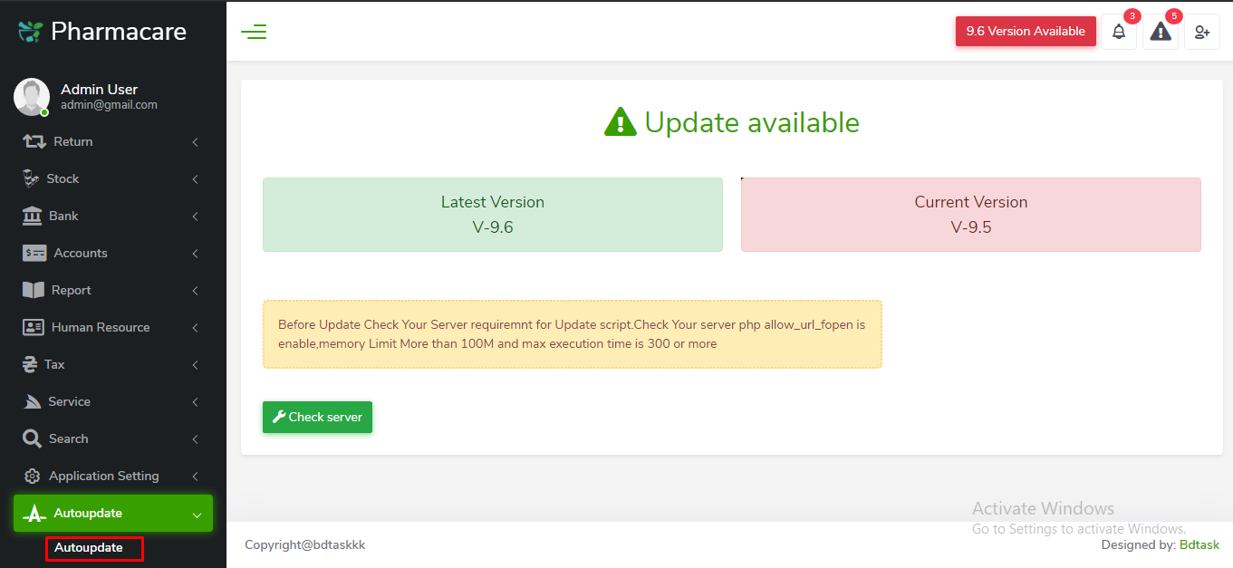

### **Forget Password**

**Password Reset**

You may forget your password, anyhow to login to your software. In that case, during setting up your software you must need to set your valid email address in setting. By setting your email address in setting whenever you forget your password during login just click on forget password. An email will be sent to your email, you will get a link there, from there you can reset your password.

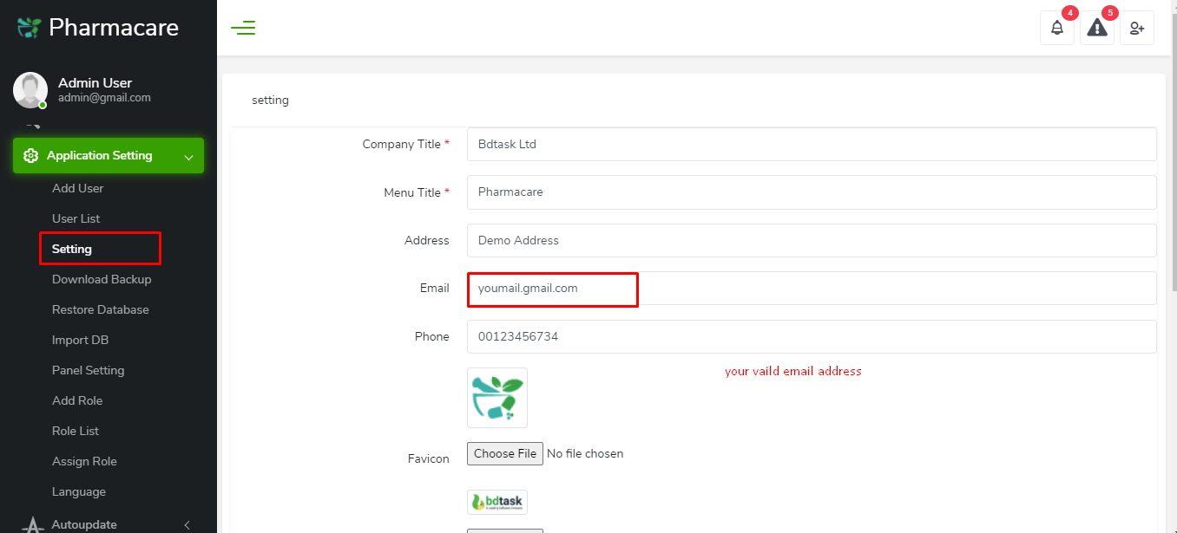

**Tax Setting**

In Tax setting you can set your product tax which will automatically calculate and show in the invoice.

N.B: If you update tax setting in the running process then all of your previous tax records will be destroyed)

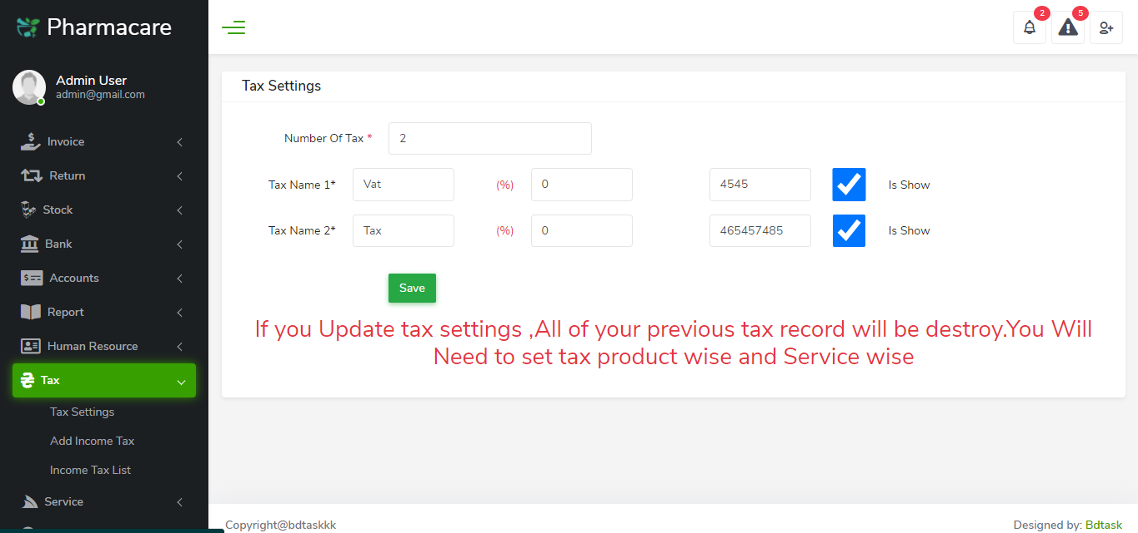

**Add manufacturer**

Now go to Add manufacturer. Here you can add manufacturer name, phone number, email address and other necessary information of the manufacturer.

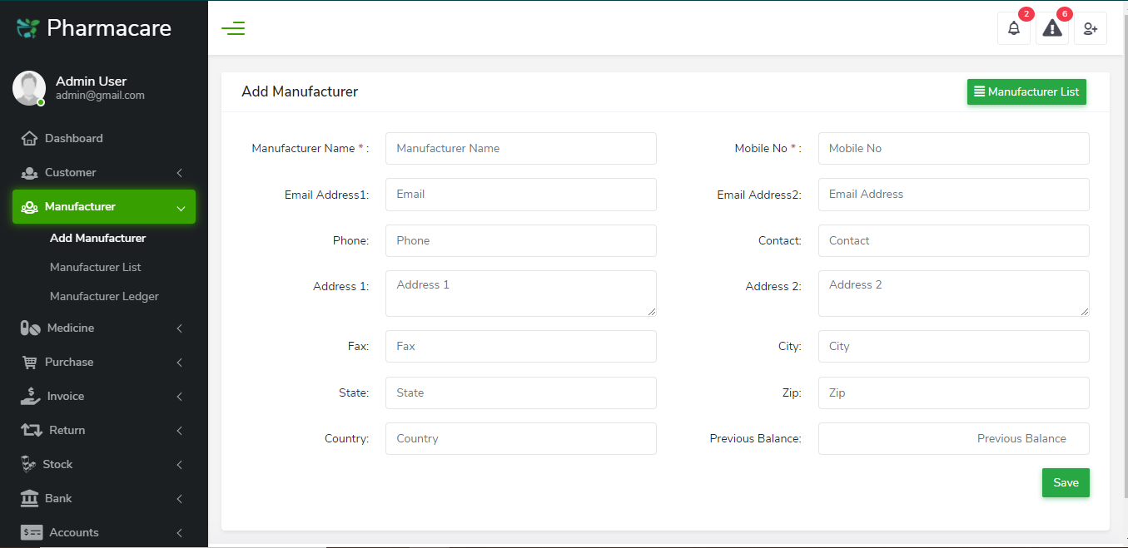

**Add Unit**

You can add different unit name of the medicines in add unit module.

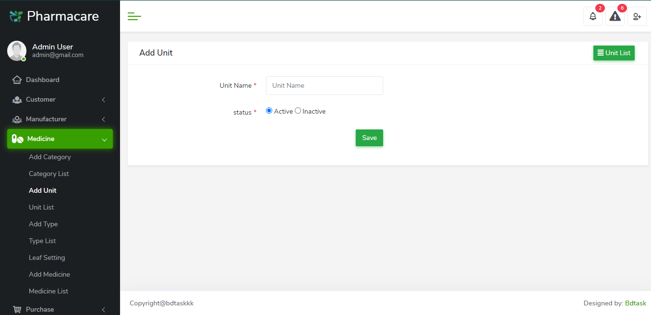

**Manufacturer Ledger**

In manufacturer ledger you can find all the details of the transactions of a manufacturer. First, select a manufacturer then select the start and end date and click the find button. All the ledger of a manufacturer will show here.

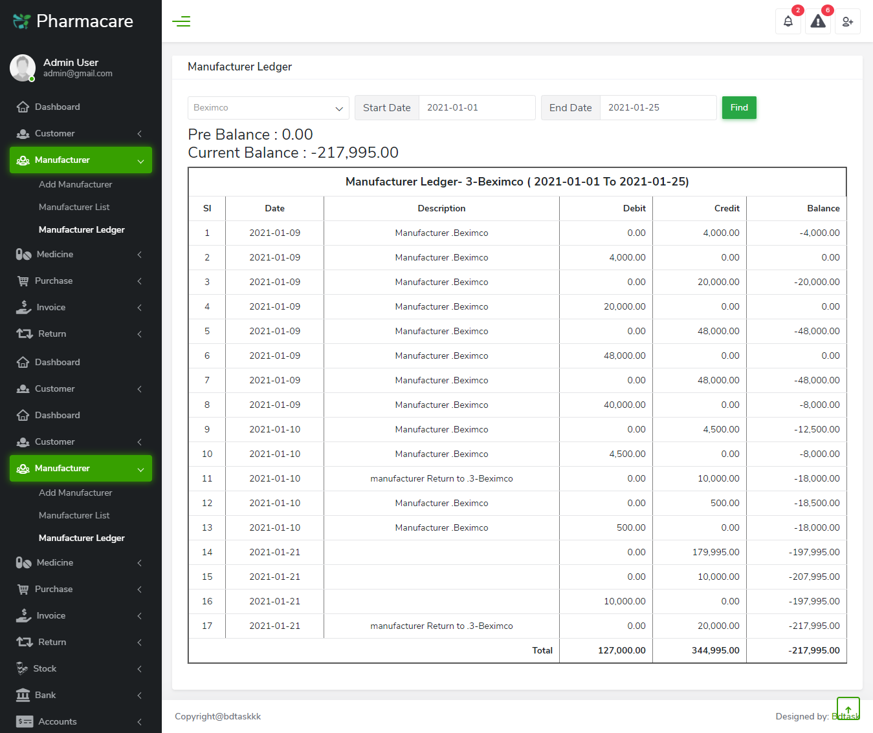

**Medicine**

